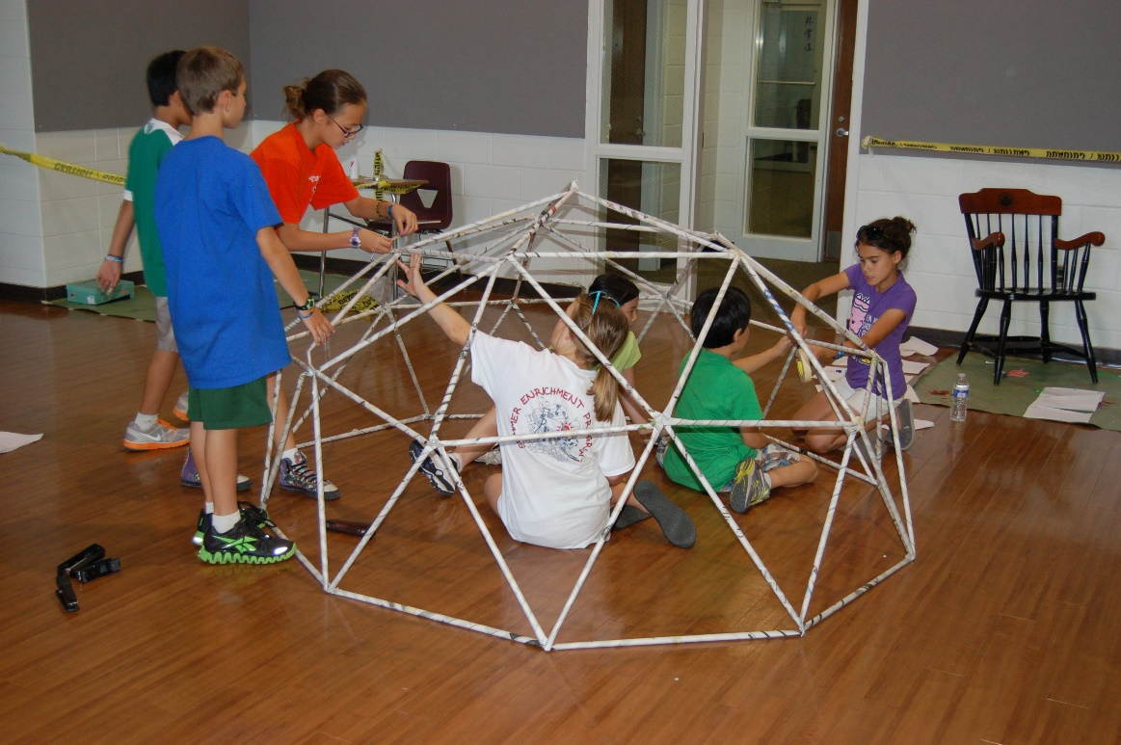

**Online application**

**Available at**

**curry.virginia.edu/sep**

Applications are available December 15,2020

and are due February 18, 2021.

Need-based financial aid available.

**Program information** available at

http://curry.virginia.edu/sep

An exciting opportunity for gifted and high ability students currently in grades 4-10!

**2021 Program Dates**

**Session I:**

**June 26- July 3**

**Session II:**

**July 4-15**

**Session III:**

**July 18-29**

For this year’s course descriptions, please visit our website.

—

The camp is a 12-day residential experience. Students live

on Grounds at UVa and attend classes at a nearby private school.

—

**Contact**

Saturday & Summer Enrichment Program

P.O. Box 400264

Charlottesville, VA 22904

434.924.3182

curry-sep@virginia.edu

University of Virginia

Curry School of Education

**2021 Summer Enrichment Program**